Finding the Census and Withdrawal Dates in Self Service
Follow these steps to access Self Service:
Start at the GTCC website: www.gtcc.edu
- Click on the Menu (hamburger)

- Choose “Self Service”
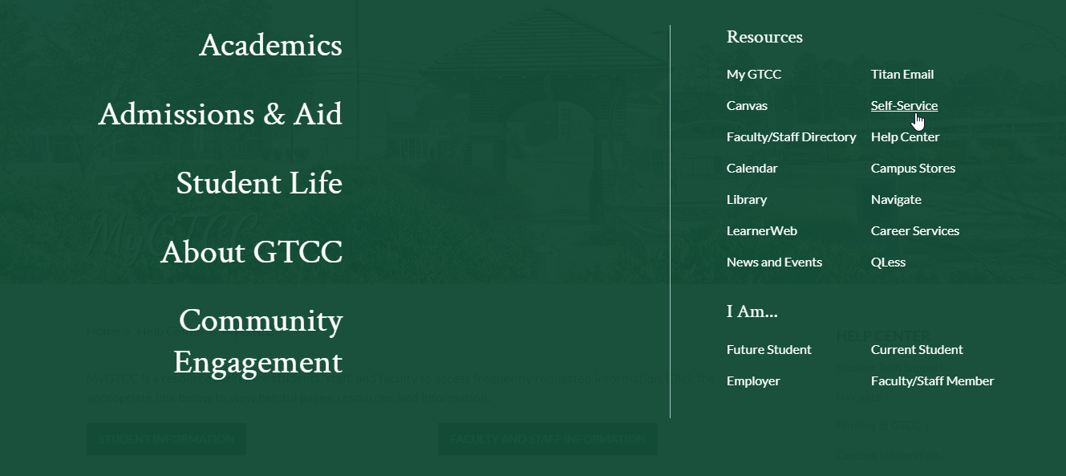

- Log in/authenticate if prompted to do so.
- Choose “Faculty”
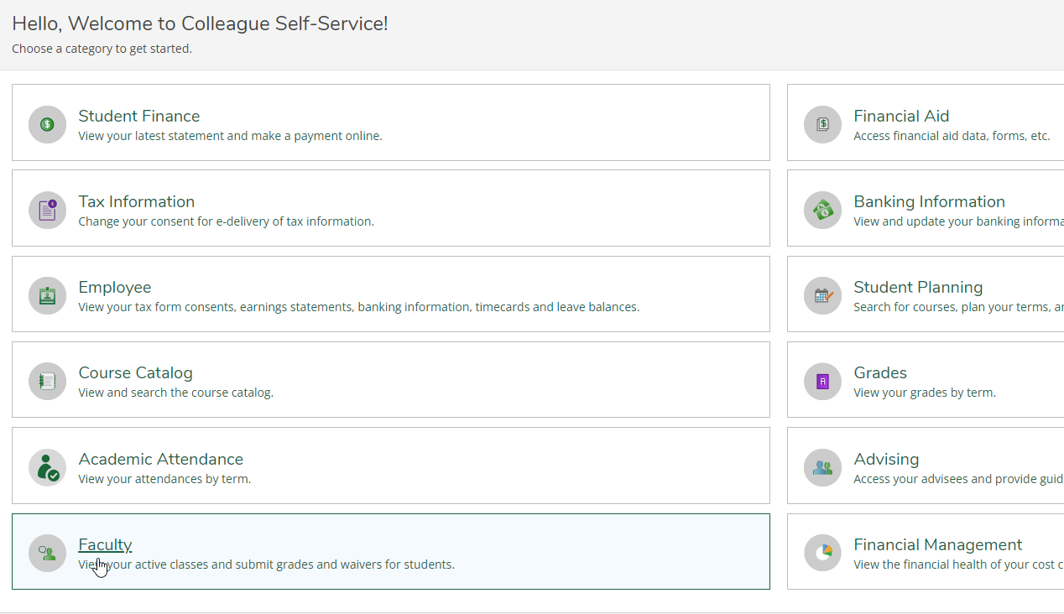
- Select your course:
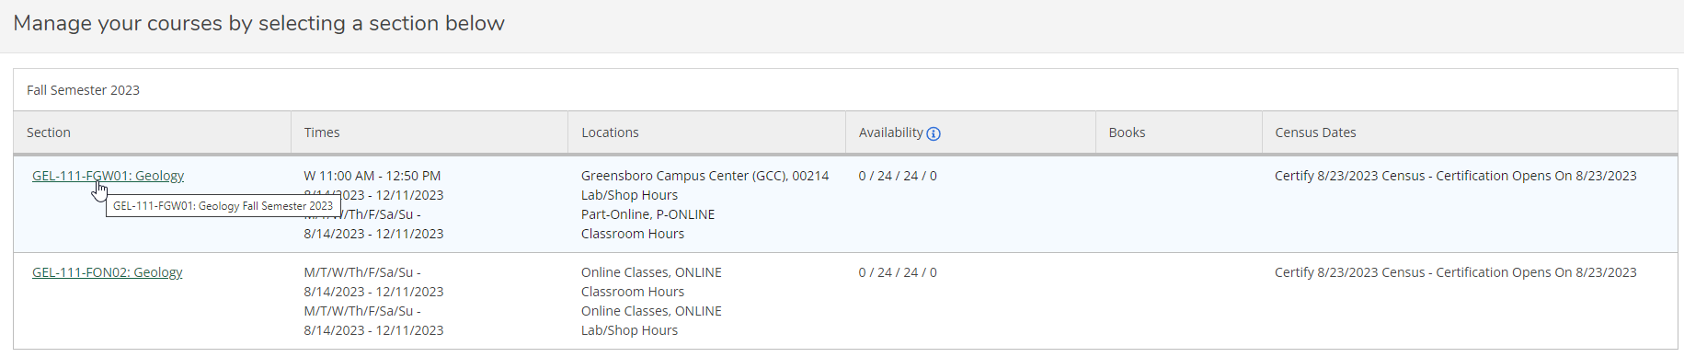
- Select “Deadline Dates”
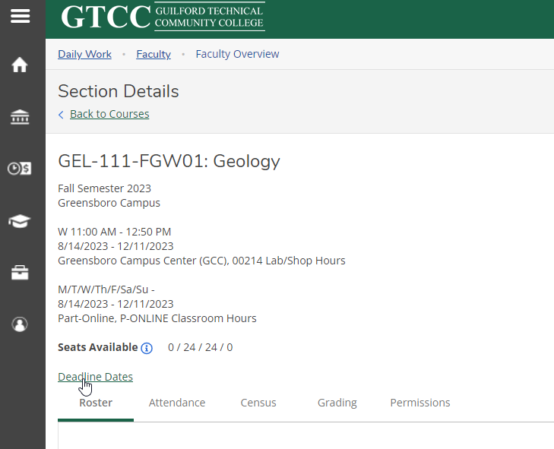
- The Census date is the “Last Day to Drop without a Grade” The withdrawal date is the “Last Day to Drop with a Grade”.
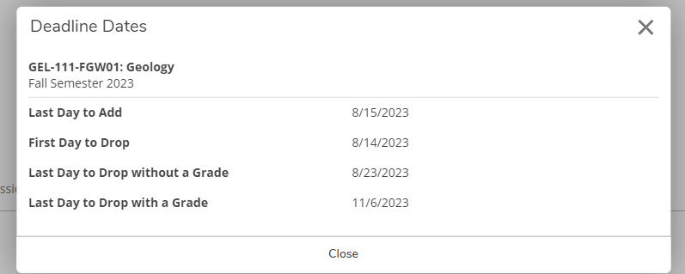
Withdrawal Date
Census Date

